

***content***

1. **Contributors**
   1. - Dimitar Ivanov – Scrum Trainer – made the documentation, README file and made the team logo
   2. - Ivan Ivanov – Front End Developer – worked on the HTML and CSS and helped with the documentation
   3. - Todor Zafirov – Back End Developer – Worked on the JS and helped with the presentation
   4. - Andrey Andreev - Designer
2. **Goals**

2.1 – Our goal is to make a website that can be easy for use and offer you the ability to send a message to the Fire department with a couple of clicks and a registration.

1. **Steps of realisation**
   1. - Organisation:

Our first step was to gather up and plan how the project would look and function

* 1. - Realisation:

Our second step was to get the website and repository done and look for anything to improve.

* 1. - Presentation

Our last step was to finish the documentation and presentation and get it to its final form.

1. **Issues while working**
   1. - Lack of communication
   2. - Github Issues
2. **Used technologies**
   1. – Discord – used for communication and organization
   2. - Visual studio code – used for making the code for the webpage
   3. - Github – used for uploading all the files and progress.
   4. - MS word – Used for the documentation
   5. MS PowerPoint – used for the presentation
3. **Functions**
   1. Function alerForm()

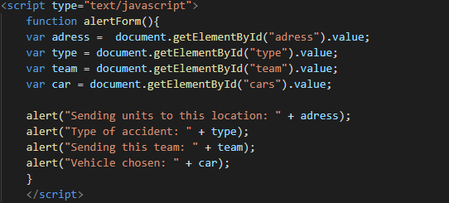

Creates variables for the different options listed in the form and then alerts them as a sign that the form has been submitted.